**F-Lab #1**

Design, analysis, and prototyping of a self-locking robotic clamp

Group Name: ___________

Members

Name (leader): _________________________ ID: __________________________

Name : ______________________ ___ ID: __________________________

Name: __________________________ ID: __________________________

Name: __________________________ ID: __________________________

Name: __________________________ ID: __________________________

We ask you to build a small robot clamp using linkages. This activity may motivate you to an in-depth learning of linkages and the toggle positions for self-locking configuration.

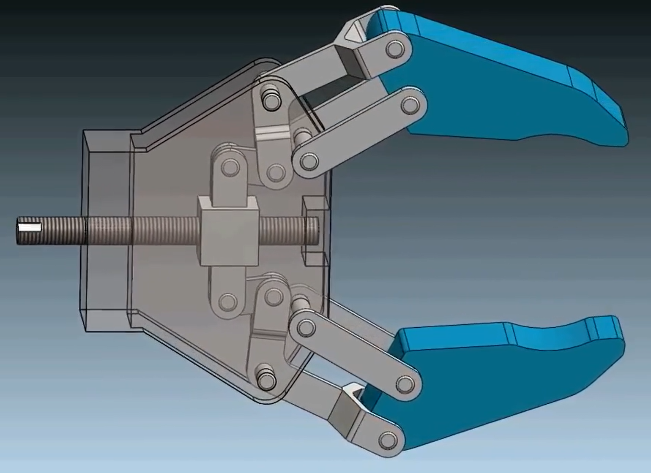

*Sample videos: Check CANVAS and lab slides

*Note*: Your device does not have to be the same as the one in the videos; you may choose different materials for parts, dimensions, and even leg types.

**Parts and tools needed**

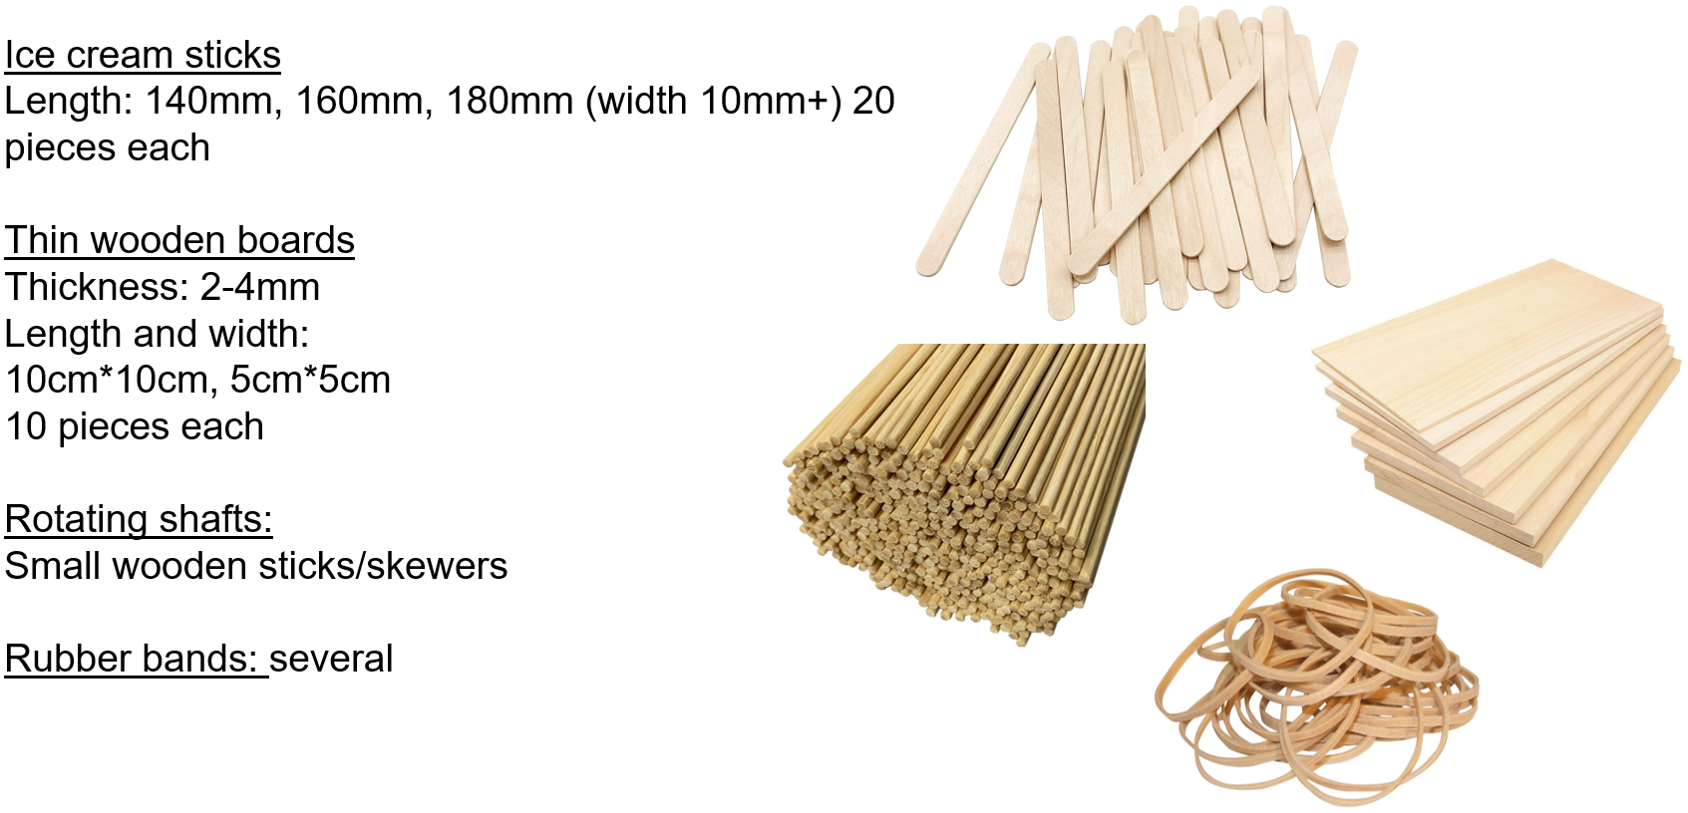

While prototyping, you may answer these questions and include them in your **technical report (~ 2 to 3 pages)**.

1. Design (synthesize) linkages to your clamp model considering the required self-locking target.
   1. Draw a sketch on your device (including linkages) with materials information. Justify the dimension of your device related to the function of the robot. (You may **not** need to use a CAD drawing at this assignment. If you insist, you may use it.)
   2. You may check **the Toggle position** on your design of linkages.
      1. How many linkages are used in your device?
      2. Is the linkage you designed a Grashof or non-Grashof case?
2. Discuss how to achieve locking & unlocking functions.
   1. Toggle position(s) identification.
   2. Dimension for the whole device and required deformation to achieve locking.
   3. Actuation method for locking and unlocking of the device.
3. Discuss some issues on your synthesis.
   1. Identify some technical problems to resolve and propose a correction of your design.
   2. Modify your design and device in Step 1 and iterate Step 2.
      1. Conduct a comparison study between before- and after- modification.
4. Describe team members’ contribution.
   1. e.g., member A – design of linkages, member B – analysis, member C- building some components of the device, member D- design and making the clamps, etc.

Submission types:

1. The device your group has prototyped (a video file) - **50 points**
2. Report (~ 2 -3 pages) – **50 points**